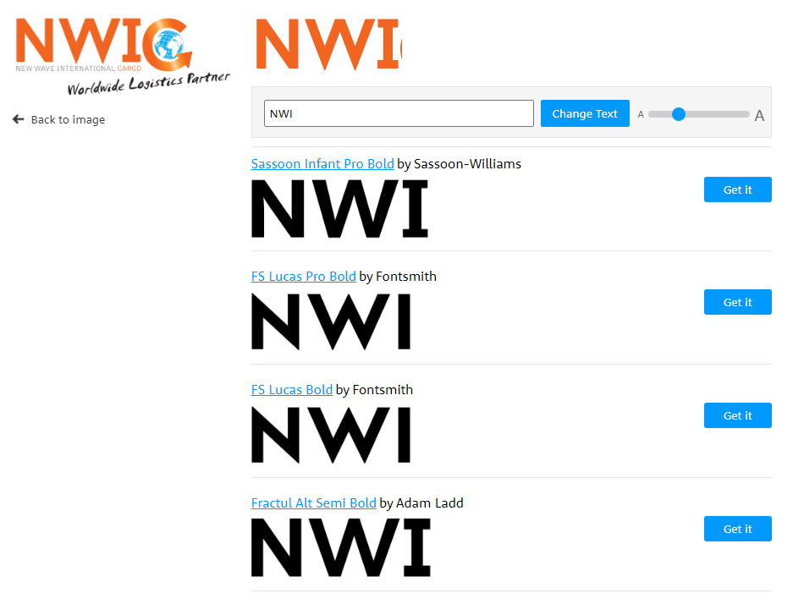

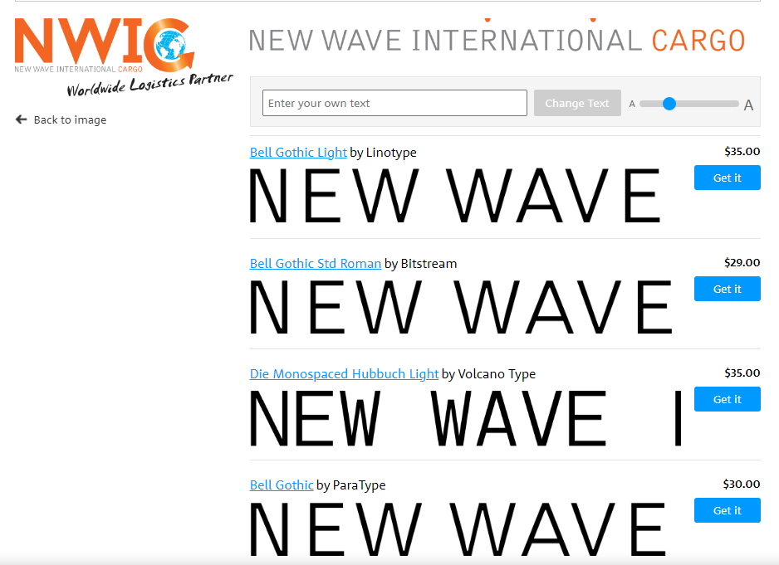

NEW WAVE - to prawdopodobnie Bell Gothic Light

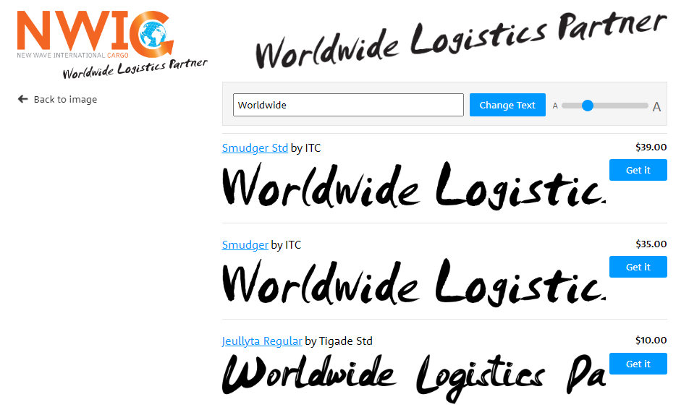

Worldwide Logistic – font SMUDGER