Good afternoon!
Our company is engaged in construction tools in Republic of Moldova.
It is necessary to develop a design for a line of building tools. We would like all the tools to be united by a common corporate style, so that they look attractive on a shelf and next to each other.
Name of our company / brand / initiatives / service: Profmet
Graphic design will be used: for formalizing of the construction tool.
Preferred colors: red, black, gray, white (according to the brand book)
Preferred style: ______________________
Additional Notes:

Type 1.Tool with fiberglass handle
The line of these tools includes: hammer, ax.
1. Hammer (Type_1_01)
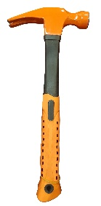
2. Ax (Type_1_02)
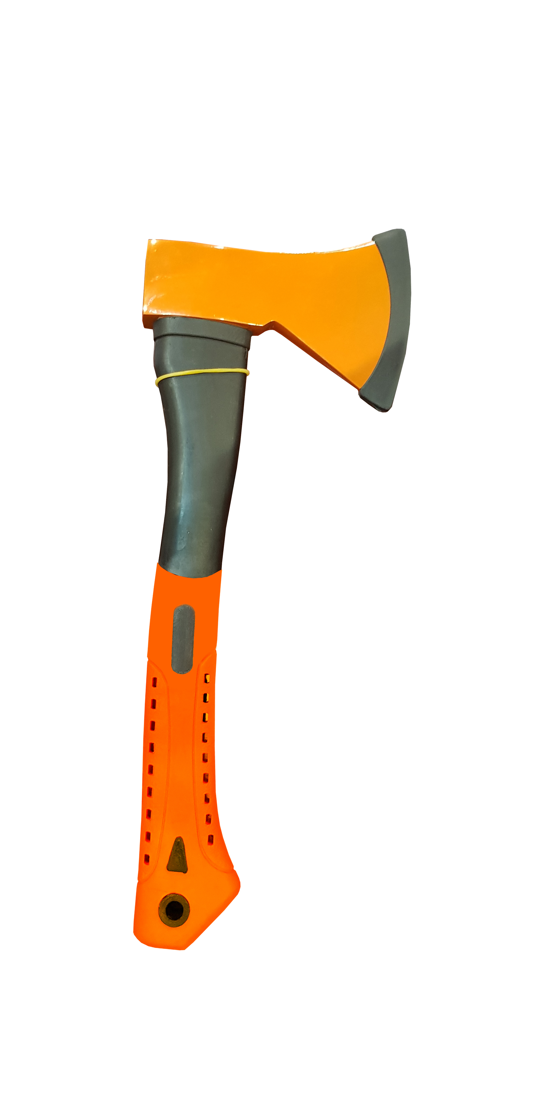
All these tools will be in the same line. We can make the handle of a red color (preferable) and make the working part of the tool of a red color (which is orange now) (preferable).
We can put a logo on the black part of the handle of the tools.
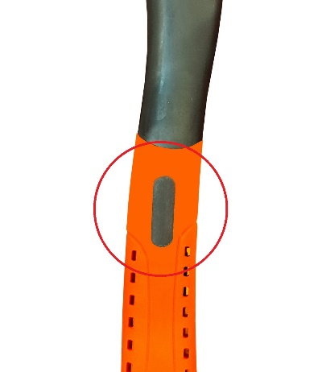
It is also necessary to develop a label for the tool.
Here’s an example of how it can be held on, you can offer other options as well.
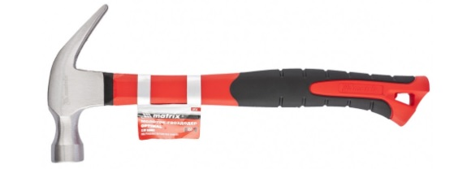
The label should contain:

1. Logo
2. Tool name
Text for Type_1_01 title - Ciocan pentru lăcătuș
Text for Type_1_02 title - Topor
3. Articul
art. 123123
4. Barcode (2 cm wide)
5. Information about the tool handle material
Text –
Mâner din două componente
6.Importer Information
Text -
Importator: “Profmet Grup” SRL
Moldova, Chisinau MD-2059, str. Petricani 33
7. Quality Mark
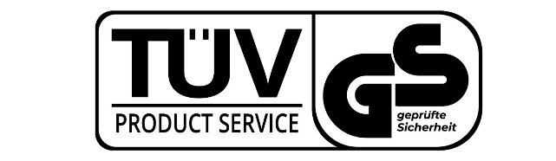
Type 2. The tool with the wooden handle.
The line of these tools includes: hammer, ax.
1. Hammer (Type_2_01)

2. Ax Type_2_02
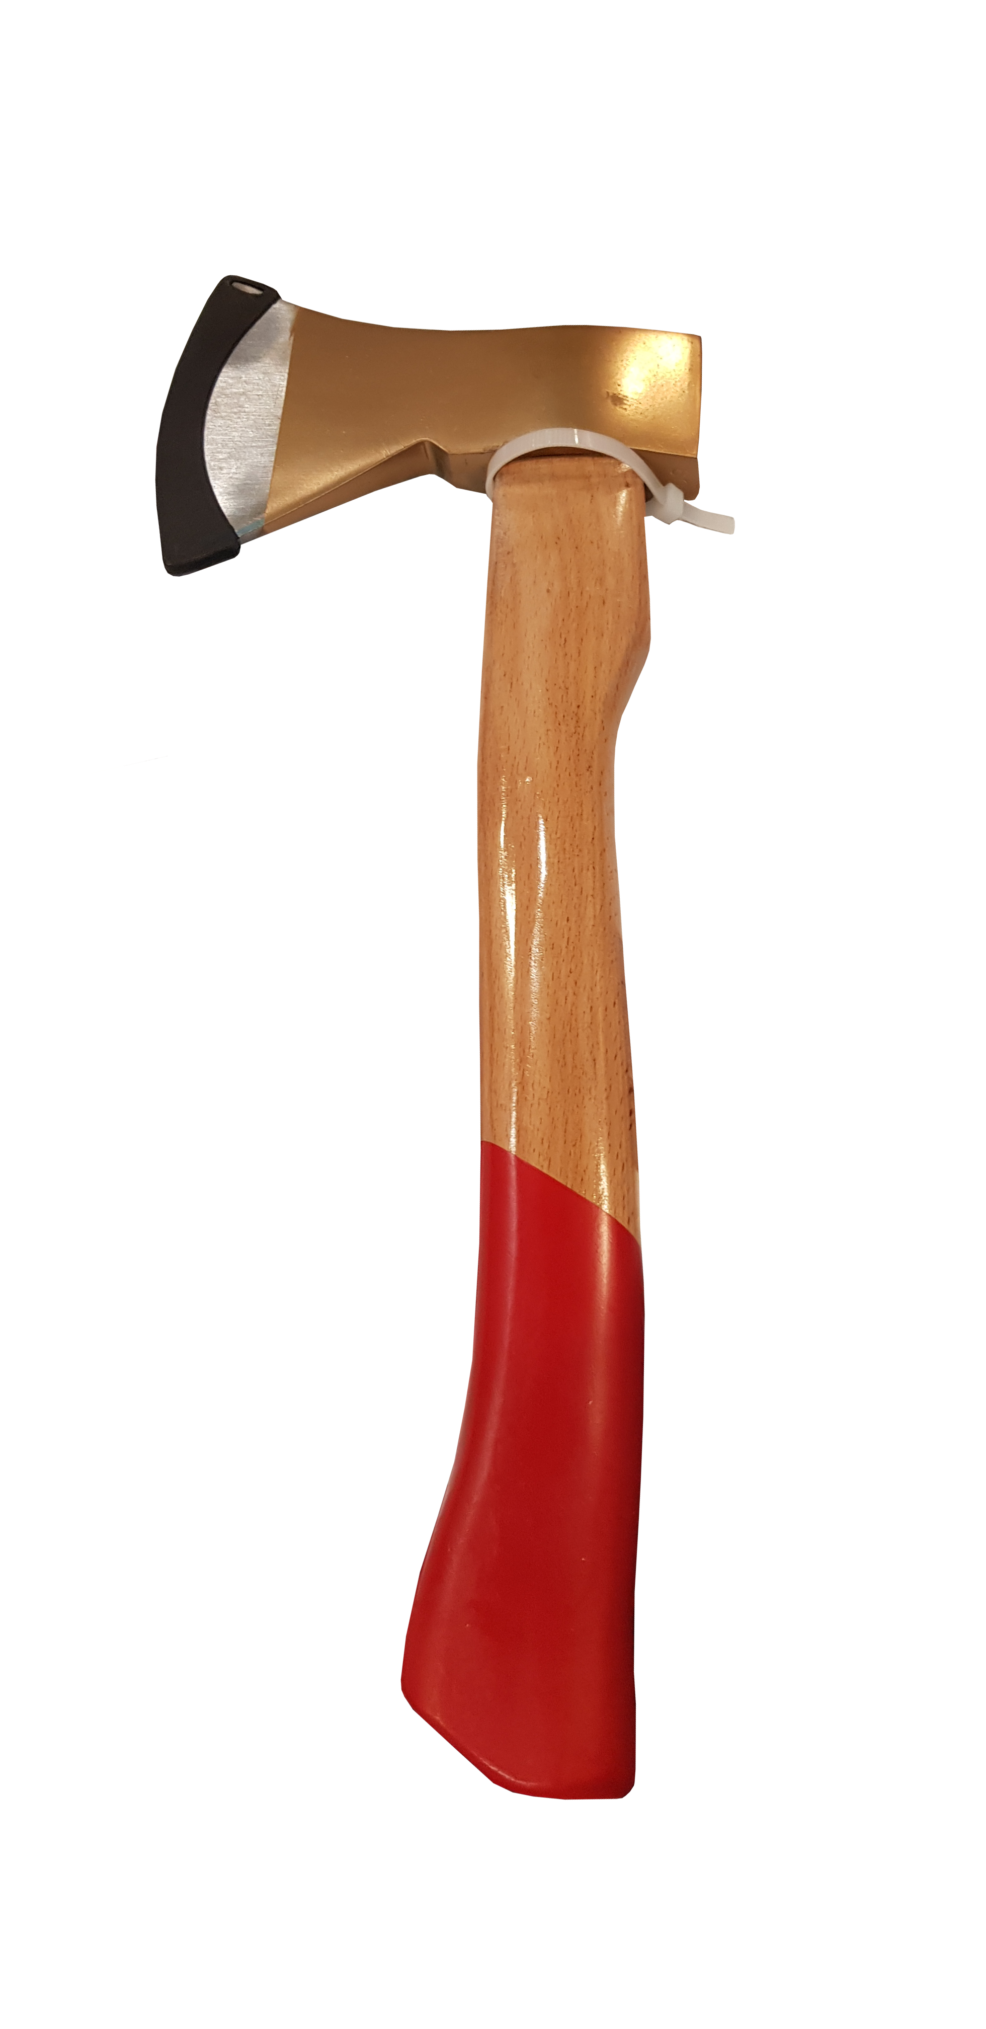

A hanging hole must be made in the handle of the instrument (as in a tool with a two-component handle)
The tool handle may remain red (as in the examples)
Ax (Type_2_02) instead of gold color it can be painted in red color.
The company logo can be applied on the handle of the tool. An engraving can be made. Or you can offer your variant of the location and logo application, so that it looks good.
It is also necessary to put a quality mark.

It is also necessary to develop a label for the tool.
Here is an example of how it can be held on, you can offer other options as well.
The label should contain:
1. Logo
2. Tool name
Text for Type_1_01 title -Ciocan pentru lăcătuș
Text for Type_1_02 title -Topor
3. Articul
art. 123123
4. Barcode (2 cm wide)
5. Information about the tool handle material
Text -
6.Importer Information
Text -
Importator: “Profmet Grup” SRL
Moldova, Chisinau MD-2059, str. Petricani 33

_______________________
It is also necessary to develop a common design for a line of building tapes measure.
The line will consist of three positions. It is necessary to develop a common corporate style for all tapes measure to match the corporate style of the brand.
It is necessary to indicate the following information on the tapes measure.

* The text that should be on the instrument is marked in red.
1. Logo Profmet
2. Tape measure length
5 m
3. Width canvas of tape measure
25 mm
4. Articul of the goods
art. 123123
* If necessary, we can change the color of the tape measure body.
It is necessary to indicate the following information on the tape measure labels:
On the front side
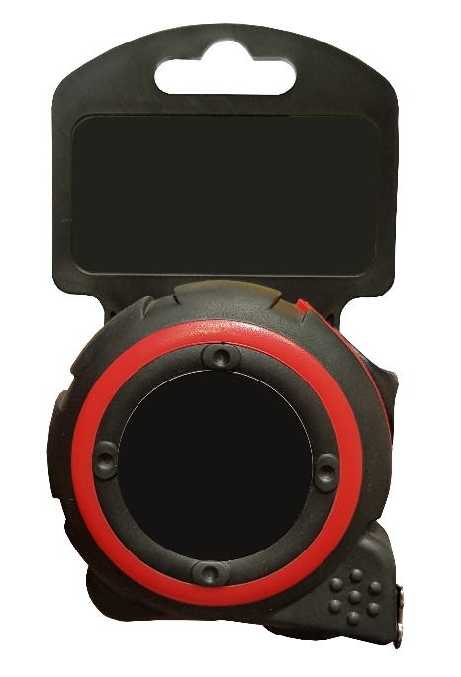
1. Logo Profmet
2. Tape measure length
5 m
3. Width canvas of tape measure
25 mm
4. Articul of the goods
art. 123123
On the back of the label
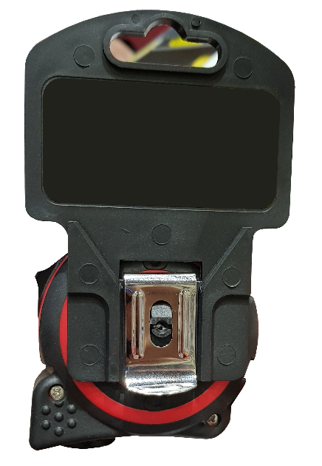

1. Logo Profmet
2. Tape measure length
5 m
3. Width canvas of tape measure
25 mm
4. Articul of the goods
art. 123123
5. Barcode (2 cm wide)
6. Importer Information
Text -
Importator: “Profmet Grup” SRL
Moldova, Chisinau MD-2059, str.Petricani 33

